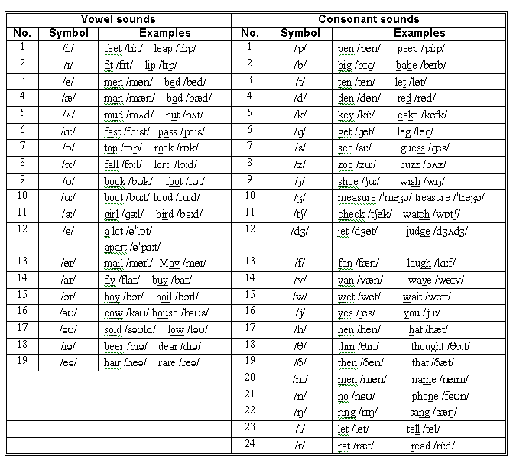

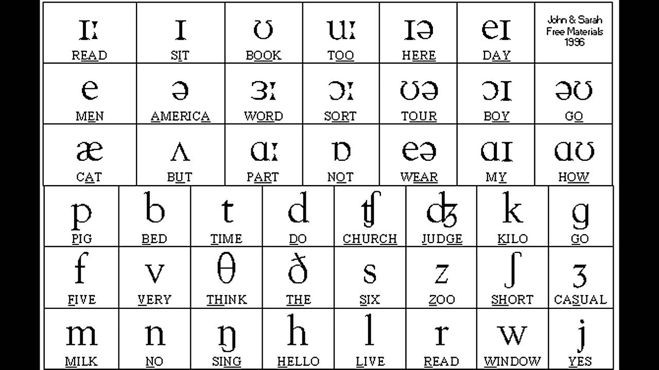

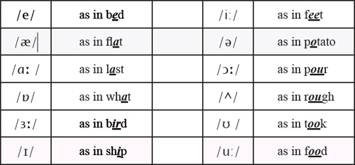

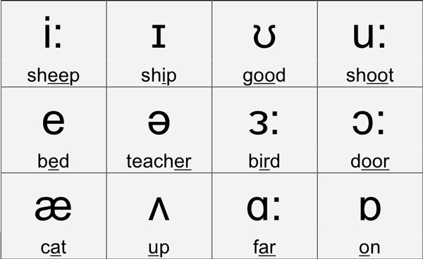

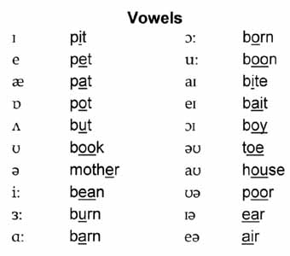



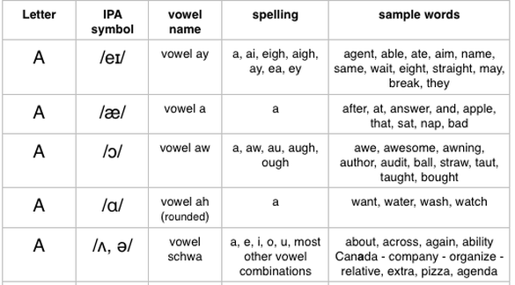

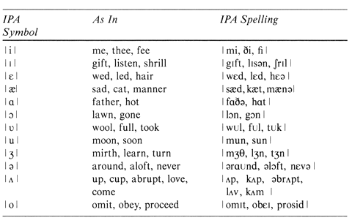

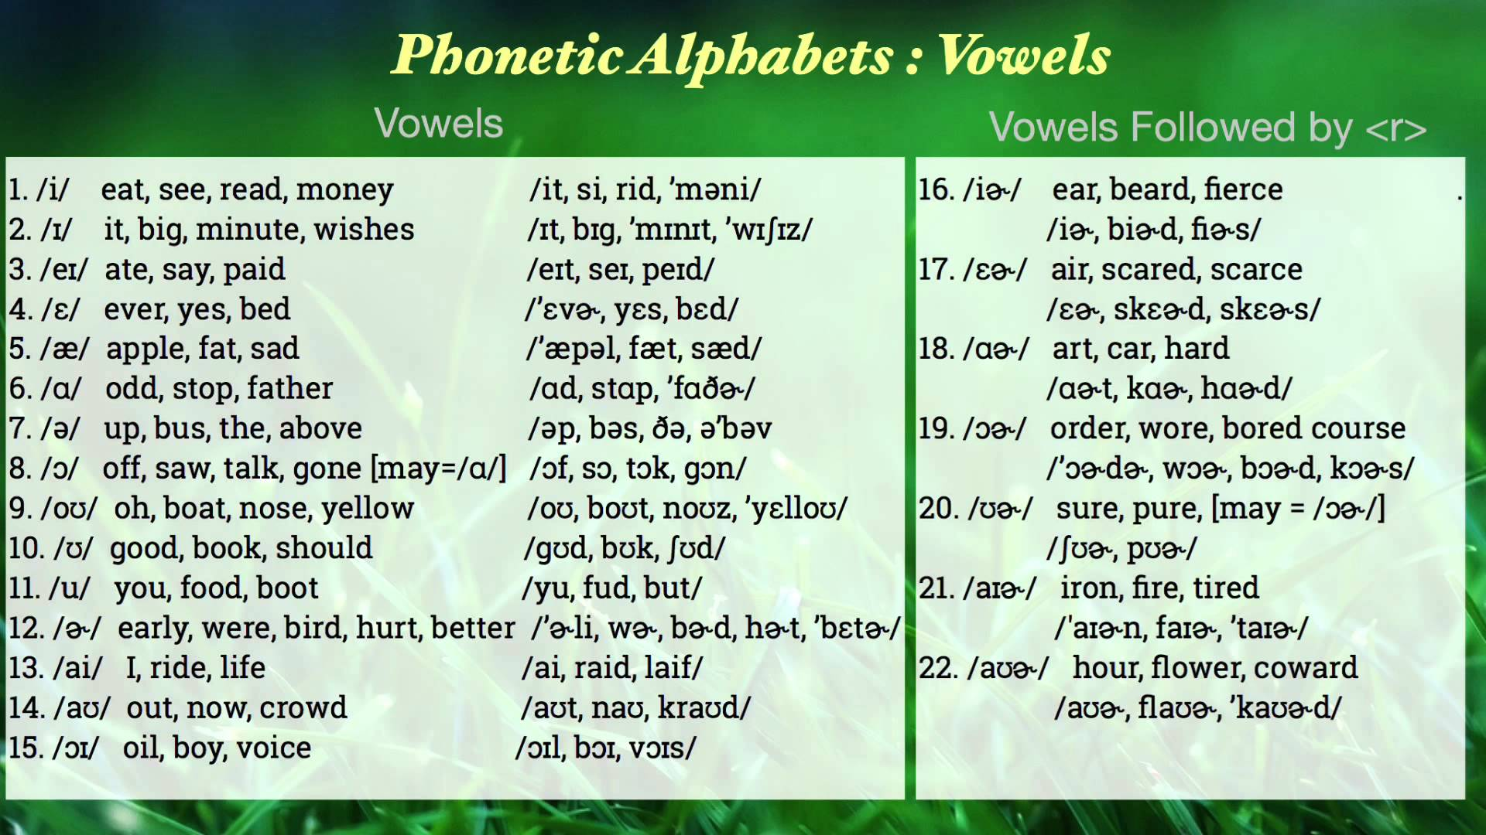

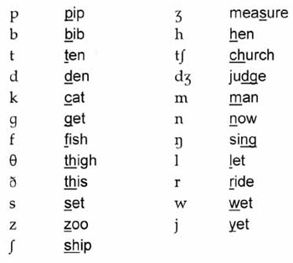

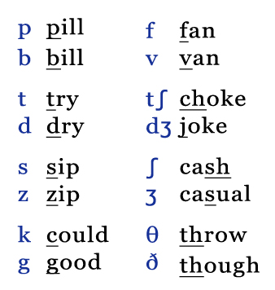

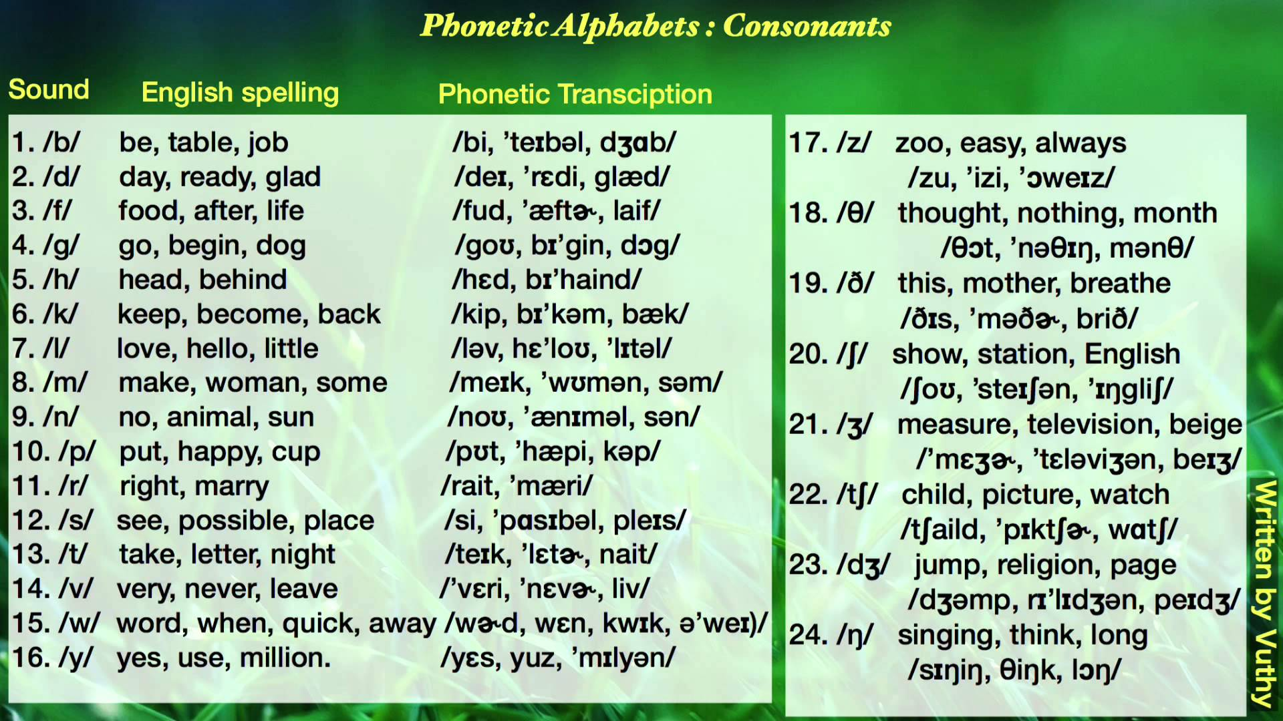

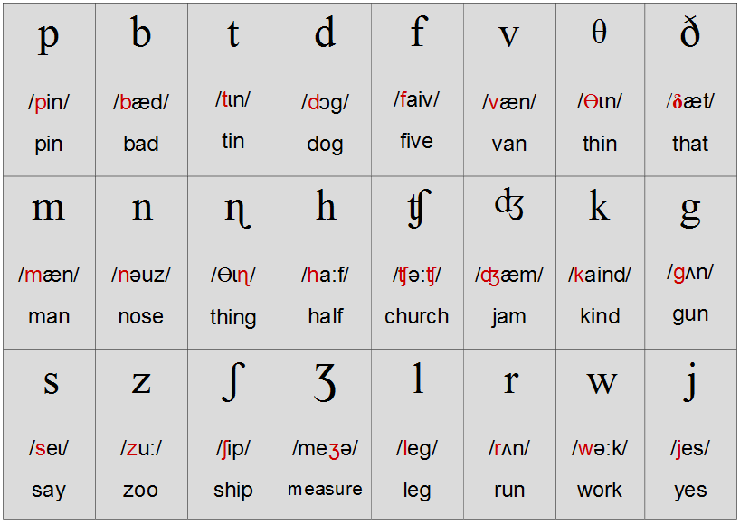



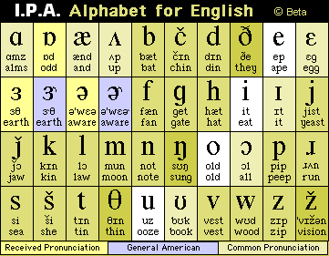

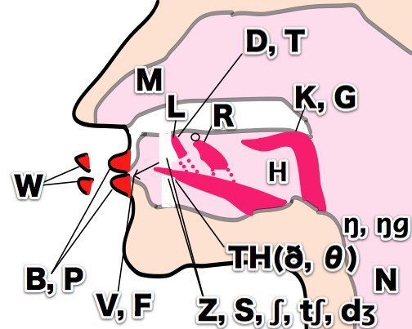

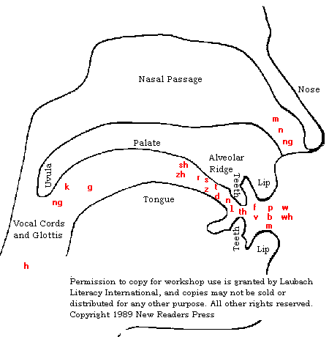

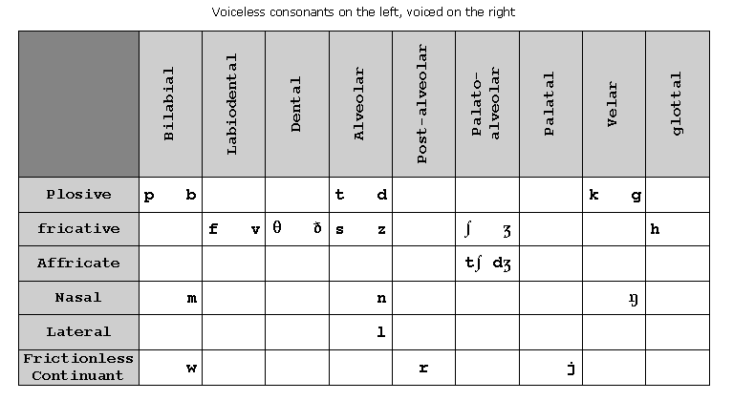

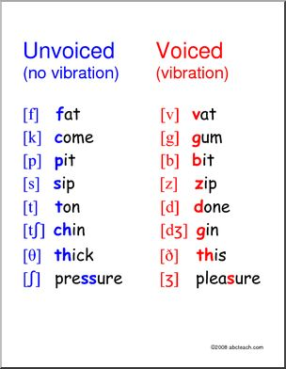

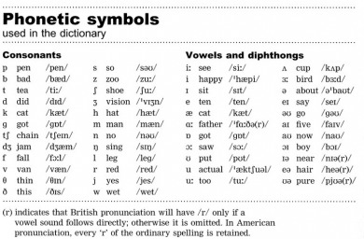

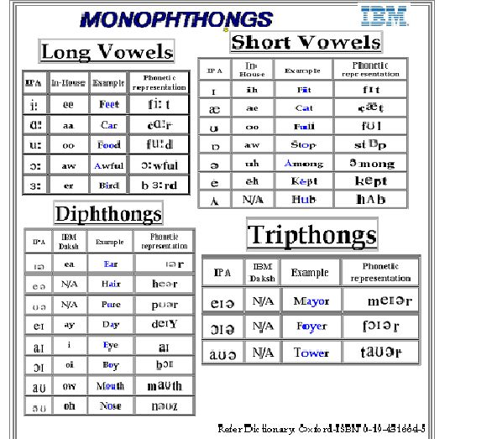

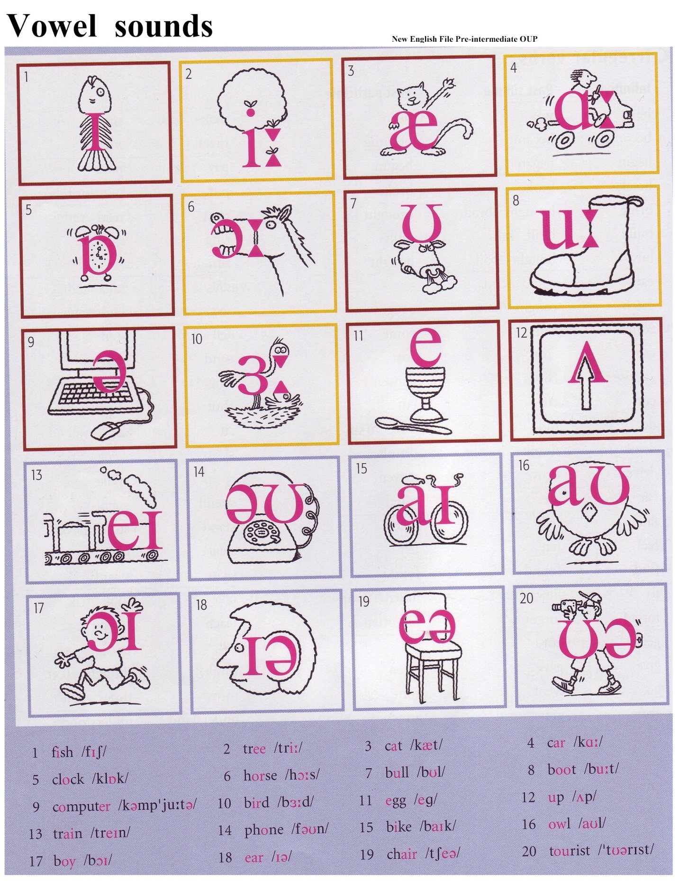

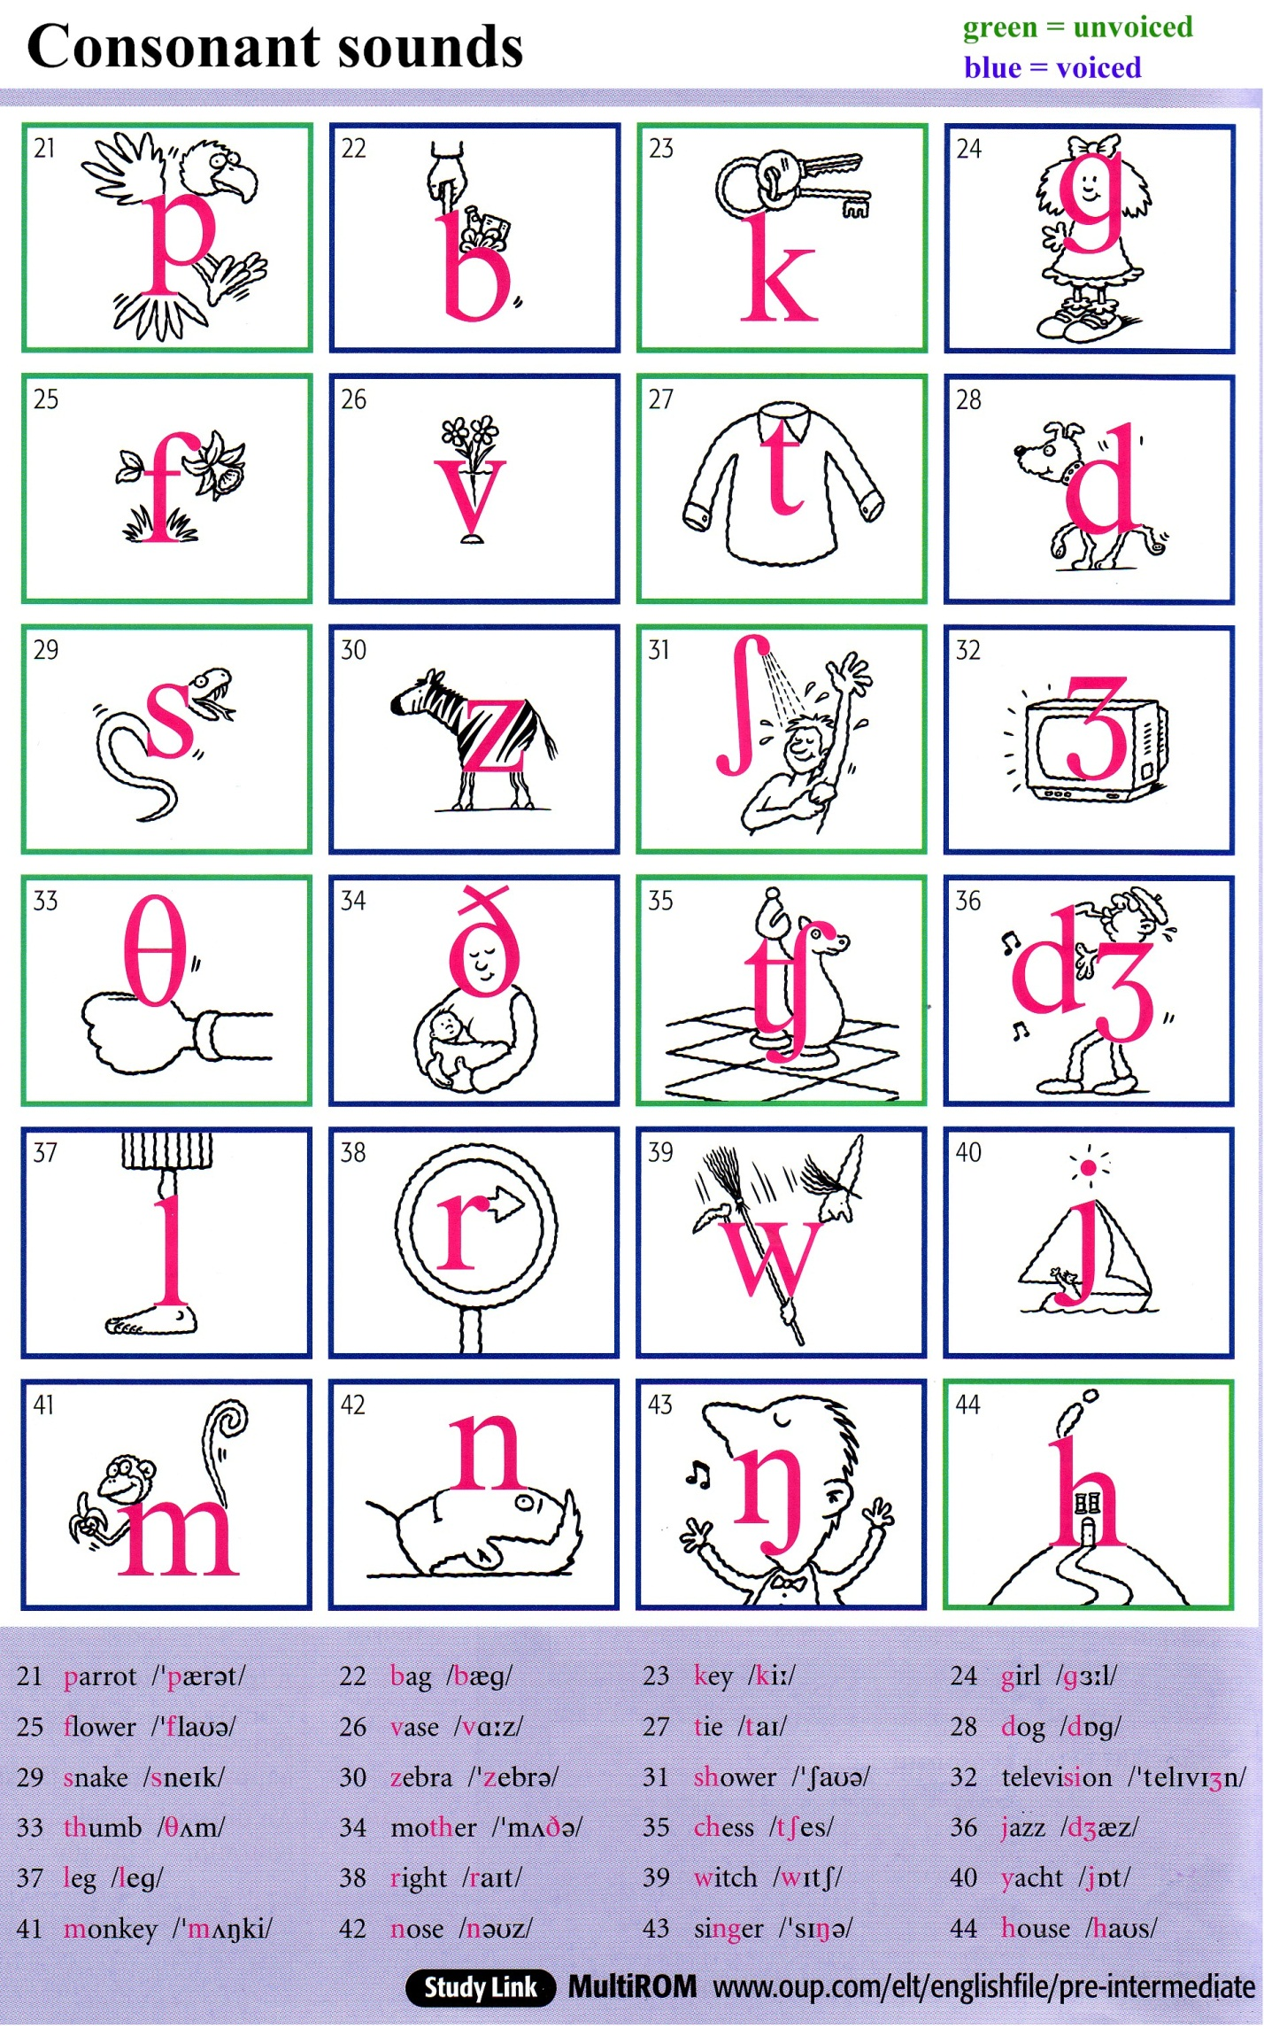

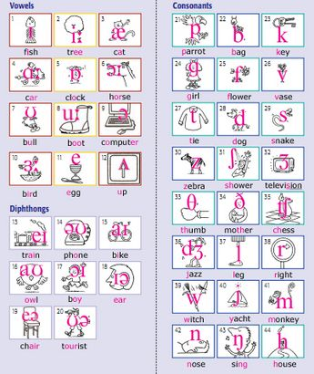

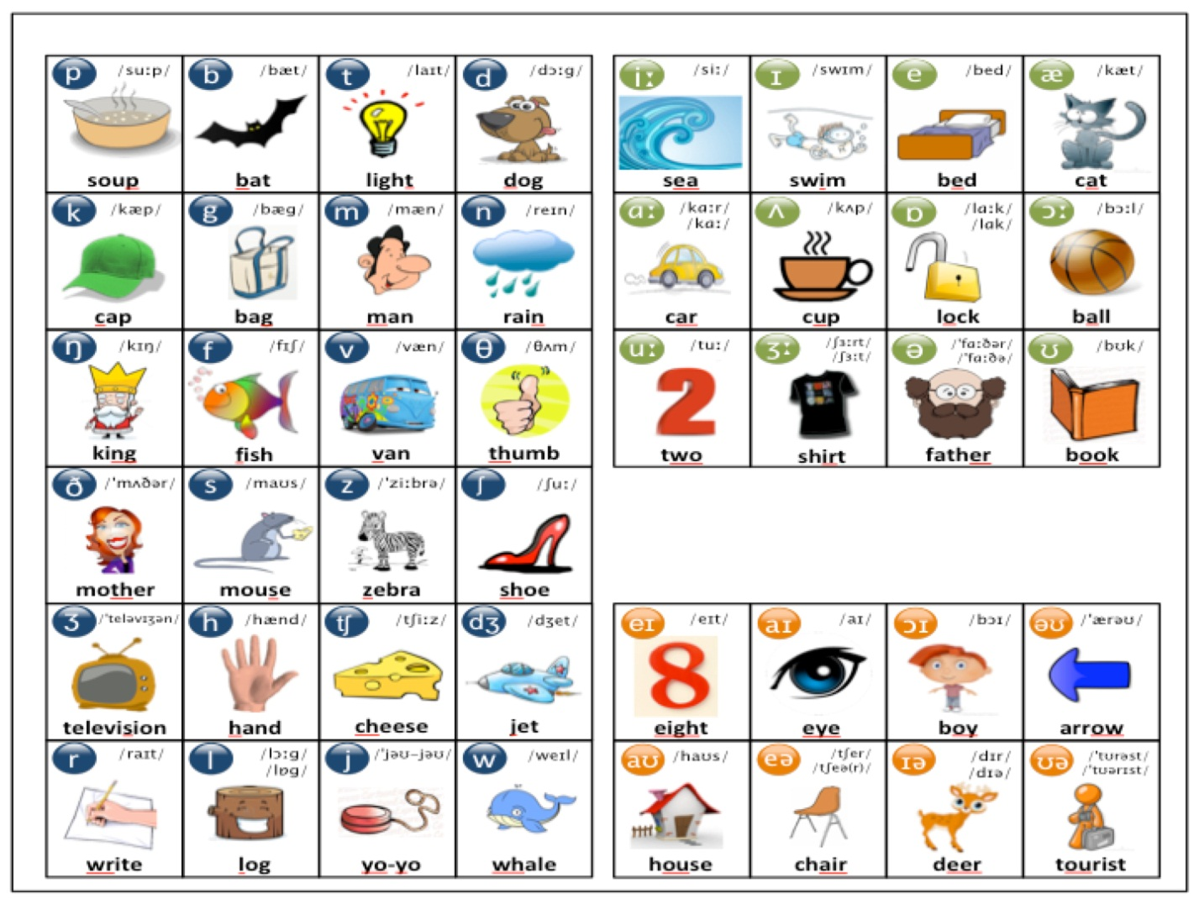

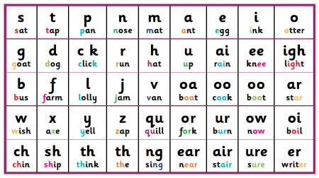

|  |  |  |  |
| --- | --- | --- | --- |
| **English Consonant Sounds** | | | |
| **IPA** | **initial** | **internal** | **final** |
| **p** | [**p**lease](http://www.elearnenglishlanguage.com/sounds/please.wav) (pliz) | [pur**p**le](http://www.elearnenglishlanguage.com/sounds/purple.wav) (phttp://cdn-2.elearnenglishlanguage.com/blog/graphics/IPA/ur-surf.jpgphttp://cdn-4.elearnenglishlanguage.com/blog/graphics/IPA/schwa.jpgl) | [hel**p**](http://www.elearnenglishlanguage.com/sounds/help.wav)(hhttp://cdn-7.elearnenglishlanguage.com/blog/graphics/IPA/e-red.jpglp) |
|  | [a**pp**le](http://www.elearnenglishlanguage.com/sounds/apple.wav) (http://cdn-4.elearnenglishlanguage.com/blog/graphics/IPA/ae-hat.jpgphttp://cdn-4.elearnenglishlanguage.com/blog/graphics/IPA/schwa.jpgl) | [gra**pe**](http://www.elearnenglishlanguage.com/sounds/grape.wav)(gre**I**p) |
|  | | | |
| **b** | [**b**ook](http://www.elearnenglishlanguage.com/sounds/book.wav) (bhttp://cdn-3.elearnenglishlanguage.com/blog/graphics/IPA/u-put.jpgk) | [no**b**le](http://www.elearnenglishlanguage.com/sounds/noble.wav) (nhttp://cdn-0.elearnenglishlanguage.com/blog/graphics/IPA/ou-snow.jpgbhttp://cdn-4.elearnenglishlanguage.com/blog/graphics/IPA/schwa.jpgl) | [we**b**](http://www.elearnenglishlanguage.com/sounds/web.wav)(whttp://cdn-7.elearnenglishlanguage.com/blog/graphics/IPA/e-red.jpgb) |  |
|  | [ca**bb**age](http://www.elearnenglishlanguage.com/sounds/cabbage.wav) (khttp://cdn-4.elearnenglishlanguage.com/blog/graphics/IPA/ae-hat.jpgb**I**g) |  |  |
|  | | | |
| **f** | [**f**ive](http://www.elearnenglishlanguage.com/sounds/5.wav) (fa**I**v) | [fi**f**ty](http://www.elearnenglishlanguage.com/sounds/50.wav) (f**I**fti) | [gul**f**](http://www.elearnenglishlanguage.com/sounds/gulf.wav) (ghttp://cdn-0.elearnenglishlanguage.com/blog/graphics/IPA/u-up.jpglf) |  |
|  | [ra**ff**le](http://www.elearnenglishlanguage.com/sounds/raffle.wav) (rhttp://cdn-4.elearnenglishlanguage.com/blog/graphics/IPA/ae-hat.jpgfhttp://cdn-4.elearnenglishlanguage.com/blog/graphics/IPA/schwa.jpgl) | [o**ff**](http://www.elearnenglishlanguage.com/sounds/off.wav)(http://cdn-3.elearnenglishlanguage.com/blog/graphics/IPA/a-not.jpgf) |  |
| [**ph**one](http://www.elearnenglishlanguage.com/sounds/phone.wav) (fhttp://cdn-0.elearnenglishlanguage.com/blog/graphics/IPA/ou-snow.jpgn) | [hy**ph**en](http://www.elearnenglishlanguage.com/sounds/hyphen.wav) (ha**I**fhttp://cdn-4.elearnenglishlanguage.com/blog/graphics/IPA/schwa.jpgn) | [nym**ph**](http://www.elearnenglishlanguage.com/sounds/nymph.wav)(n**I**mf) |  |
|  | [rou**gh**ly](http://www.elearnenglishlanguage.com/sounds/roughly.wav) (rhttp://cdn-0.elearnenglishlanguage.com/blog/graphics/IPA/u-up.jpgfli) | [tou**gh**](http://www.elearnenglishlanguage.com/sounds/tough.wav)(thttp://cdn-4.elearnenglishlanguage.com/blog/graphics/IPA/ae-hat.jpgf) |  |
|  | | | |
| **v** | [**v**anilla](http://www.elearnenglishlanguage.com/sounds/vanilla.wav) (vhttp://cdn-4.elearnenglishlanguage.com/blog/graphics/IPA/schwa.jpgn**I**lhttp://cdn-4.elearnenglishlanguage.com/blog/graphics/IPA/schwa.jpg) | [se**v**en](http://www.elearnenglishlanguage.com/sounds/7.wav) (shttp://cdn-7.elearnenglishlanguage.com/blog/graphics/IPA/e-red.jpgvhttp://cdn-4.elearnenglishlanguage.com/blog/graphics/IPA/schwa.jpgn) | [fi**ve**](http://www.elearnenglishlanguage.com/sounds/5.wav) (fa**I**v) |  |
|  | | | |  |
| http://cdn-6.elearnenglishlanguage.com/blog/graphics/IPA/th-three.jpg | [**th**irty](http://www.elearnenglishlanguage.com/sounds/30.wav) (http://cdn-6.elearnenglishlanguage.com/blog/graphics/IPA/th-three.jpghttp://cdn-2.elearnenglishlanguage.com/blog/graphics/IPA/ur-surf.jpgti) | [no**th**ing](http://www.elearnenglishlanguage.com/sounds/nothing.wav) (nhttp://cdn-0.elearnenglishlanguage.com/blog/graphics/IPA/u-up.jpghttp://cdn-6.elearnenglishlanguage.com/blog/graphics/IPA/th-three.jpg**I**ŋ) | [pa**th**](http://www.elearnenglishlanguage.com/sounds/path.wav)(phttp://cdn-4.elearnenglishlanguage.com/blog/graphics/IPA/ae-hat.jpghttp://cdn-6.elearnenglishlanguage.com/blog/graphics/IPA/th-three.jpg) |  |
|  | | | |  |
| http://cdn-2.elearnenglishlanguage.com/blog/graphics/IPA/th-those.jpg | [**th**ey](http://www.elearnenglishlanguage.com/sounds/they.wav) (http://cdn-2.elearnenglishlanguage.com/blog/graphics/IPA/th-those.jpge**I**) | [fa**th**er](http://www.elearnenglishlanguage.com/sounds/father.wav) (fhttp://cdn-3.elearnenglishlanguage.com/blog/graphics/IPA/a-not.jpghttp://cdn-2.elearnenglishlanguage.com/blog/graphics/IPA/th-those.jpghttp://cdn-2.elearnenglishlanguage.com/blog/graphics/IPA/ur-surf.jpg) | [brea**the**](http://www.elearnenglishlanguage.com/sounds/breathe.wav)(brihttp://cdn-2.elearnenglishlanguage.com/blog/graphics/IPA/th-those.jpg) |  |
|  | | | |  |
| **t** | [**t**en](http://www.elearnenglishlanguage.com/sounds/10.wav) (thttp://cdn-7.elearnenglishlanguage.com/blog/graphics/IPA/e-red.jpgn) | [au**t**umn](http://www.elearnenglishlanguage.com/sounds/autumn.wav) (http://cdn-6.elearnenglishlanguage.com/blog/graphics/IPA/aw-august.jpgthttp://cdn-4.elearnenglishlanguage.com/blog/graphics/IPA/schwa.jpgm) | [hi**t**](http://www.elearnenglishlanguage.com/sounds/hit.wav) (h**I**t) |  |
|  | [a**tt**ain](http://www.elearnenglishlanguage.com/sounds/attain.wav) (http://cdn-4.elearnenglishlanguage.com/blog/graphics/IPA/schwa.jpgte**I**n) | [mi**tt**](http://www.elearnenglishlanguage.com/sounds/mitt.wav)(m**I**t) |  |
|  | [ei**ght**y](http://www.elearnenglishlanguage.com/sounds/80.wav) (e**I**ti) | [frei**ght**](http://www.elearnenglishlanguage.com/sounds/freight.wav) (fre**I**t) |  |
|  |  | [bak**ed**](http://www.elearnenglishlanguage.com/sounds/baked.wav)*(be**I**kt) |  |
|  |  | [whi**te**](http://www.elearnenglishlanguage.com/sounds/white.wav) (we**I**t) |  |
| *[Pronunciation of simple past –***ed*** ending](http://www.elearnenglishlanguage.com/blog/learn-english/grammar/simple-past-pronunciation/) | | | |
|  | | | |
| **d** | [**d**ish](http://www.elearnenglishlanguage.com/sounds/dish.wav) (d**I**http://cdn-0.elearnenglishlanguage.com/blog/graphics/IPA/sh-shot.jpg) | [wi**d**ow](http://www.elearnenglishlanguage.com/sounds/widow.wav) (w**I**dhttp://cdn-0.elearnenglishlanguage.com/blog/graphics/IPA/ou-snow.jpg) | [re**d**](http://www.elearnenglishlanguage.com/sounds/red.wav) (rhttp://cdn-7.elearnenglishlanguage.com/blog/graphics/IPA/e-red.jpgd) |
|  | [a**dd**ing](http://www.elearnenglishlanguage.com/sounds/adding.wav) (http://cdn-4.elearnenglishlanguage.com/blog/graphics/IPA/ae-hat.jpgd**I**ŋ) | [gui**de**](http://www.elearnenglishlanguage.com/sounds/guide.wav)(ghttp://cdn-5.elearnenglishlanguage.com/blog/graphics/IPA/ai-my.jpgd) |
|  | | | |  |
| **s** | [**s**ir](http://www.elearnenglishlanguage.com/sounds/sir.wav) (shttp://cdn-2.elearnenglishlanguage.com/blog/graphics/IPA/ur-surf.jpg) | [the**s**is](http://www.elearnenglishlanguage.com/sounds/thesis.wav) (http://cdn-6.elearnenglishlanguage.com/blog/graphics/IPA/th-three.jpgishttp://cdn-4.elearnenglishlanguage.com/blog/graphics/IPA/schwa.jpgs) | [book**s**](http://www.elearnenglishlanguage.com/sounds/books.wav) (bhttp://cdn-3.elearnenglishlanguage.com/blog/graphics/IPA/u-put.jpgks) |  |
| [**sc**issors](http://www.elearnenglishlanguage.com/sounds/scissors.wav) (s**I**zhttp://cdn-2.elearnenglishlanguage.com/blog/graphics/IPA/ur-surf.jpgz) | [ma**ss**age](http://www.elearnenglishlanguage.com/sounds/massage.wav) (mhttp://cdn-4.elearnenglishlanguage.com/blog/graphics/IPA/schwa.jpgshttp://cdn-4.elearnenglishlanguage.com/blog/graphics/IPA/ae-hat.jpghttp://cdn-7.elearnenglishlanguage.com/blog/graphics/IPA/g-genre.jpg) | [mi**ss**](http://www.elearnenglishlanguage.com/sounds/miss.wav) (m**I**s) |  |
| [**c**enter](http://www.elearnenglishlanguage.com/sounds/center.wav) (shttp://cdn-7.elearnenglishlanguage.com/blog/graphics/IPA/e-red.jpgnthttp://cdn-2.elearnenglishlanguage.com/blog/graphics/IPA/ur-surf.jpg) | [De**c**ember](http://www.elearnenglishlanguage.com/sounds/december.wav) (d**I**shttp://cdn-7.elearnenglishlanguage.com/blog/graphics/IPA/e-red.jpgmbhttp://cdn-2.elearnenglishlanguage.com/blog/graphics/IPA/ur-surf.jpg) | [i**ce**](http://www.elearnenglishlanguage.com/sounds/ice.wav)(is) |  |
| [**ps**ychology](http://www.elearnenglishlanguage.com/sounds/psychology.wav) (sa**I**khttp://cdn-3.elearnenglishlanguage.com/blog/graphics/IPA/a-not.jpglhttp://cdn-4.elearnenglishlanguage.com/blog/graphics/IPA/schwa.jpggi) |  | [si**x**](http://www.elearnenglishlanguage.com/sounds/6.wav) (s**I**ks) |  |
|  |  | [hou**se**](http://www.elearnenglishlanguage.com/sounds/house.wav)(hhttp://cdn-5.elearnenglishlanguage.com/blog/graphics/IPA/au-cow.jpgs) |  |
|  | | | |
| **z** | [**z**ero](http://www.elearnenglishlanguage.com/sounds/0.wav) (zhttp://cdn-2.elearnenglishlanguage.com/blog/graphics/IPA/Ir-here.jpghttp://cdn-0.elearnenglishlanguage.com/blog/graphics/IPA/ou-snow.jpg) | [free**z**ing](http://www.elearnenglishlanguage.com/sounds/freezing.wav) (friz**I**ŋ) | [oo**ze**](http://www.elearnenglishlanguage.com/sounds/ooze.wav)(uz) |
|  | [fu**zz**y](http://www.elearnenglishlanguage.com/sounds/fuzzy.wav) (fhttp://cdn-0.elearnenglishlanguage.com/blog/graphics/IPA/u-up.jpgzi) | [ja**zz**](http://www.elearnenglishlanguage.com/sounds/jazz.wav)(http://cdn-6.elearnenglishlanguage.com/blog/graphics/IPA/dz-jug.jpghttp://cdn-4.elearnenglishlanguage.com/blog/graphics/IPA/ae-hat.jpgz) |
|  | [mi**s**er](http://www.elearnenglishlanguage.com/sounds/miser.wav) (ma**I**zhttp://cdn-2.elearnenglishlanguage.com/blog/graphics/IPA/ur-surf.jpg) | [dishe**s**](http://www.elearnenglishlanguage.com/sounds/dishes.wav) (d**I**http://cdn-0.elearnenglishlanguage.com/blog/graphics/IPA/sh-shot.jpghttp://cdn-4.elearnenglishlanguage.com/blog/graphics/IPA/schwa.jpgz) |
| [**x**enophobe](http://www.elearnenglishlanguage.com/sounds/xenophobe.wav) (zhttp://cdn-7.elearnenglishlanguage.com/blog/graphics/IPA/e-red.jpgnhttp://cdn-4.elearnenglishlanguage.com/blog/graphics/IPA/schwa.jpgfhttp://cdn-0.elearnenglishlanguage.com/blog/graphics/IPA/ou-snow.jpgb) | [e**x**it](http://www.elearnenglishlanguage.com/sounds/exit.wav) (http://cdn-7.elearnenglishlanguage.com/blog/graphics/IPA/e-red.jpggz**I**t) | [plea**se**](http://www.elearnenglishlanguage.com/sounds/please.wav) (pliz) |  |
|  | [sci**ss**ors](http://www.elearnenglishlanguage.com/sounds/scissors.wav) (s**I**zhttp://cdn-2.elearnenglishlanguage.com/blog/graphics/IPA/ur-surf.jpgz) |  |  |
|  | | | |  |
| http://cdn-0.elearnenglishlanguage.com/blog/graphics/IPA/sh-shot.jpg | [**sh**e](http://www.elearnenglishlanguage.com/sounds/she.wav) (http://cdn-0.elearnenglishlanguage.com/blog/graphics/IPA/sh-shot.jpgi) | [mu**sh**room](http://www.elearnenglishlanguage.com/sounds/mushroom.wav) (mhttp://cdn-0.elearnenglishlanguage.com/blog/graphics/IPA/u-up.jpghttp://cdn-0.elearnenglishlanguage.com/blog/graphics/IPA/sh-shot.jpgrum) | [radi**sh**](http://www.elearnenglishlanguage.com/sounds/radish.wav)(rhttp://cdn-4.elearnenglishlanguage.com/blog/graphics/IPA/ae-hat.jpgd**I**http://cdn-0.elearnenglishlanguage.com/blog/graphics/IPA/sh-shot.jpg) |
| [**s**ure](http://www.elearnenglishlanguage.com/sounds/sure.wav) (http://cdn-0.elearnenglishlanguage.com/blog/graphics/IPA/sh-shot.jpghttp://cdn-2.elearnenglishlanguage.com/blog/graphics/IPA/ur-surf.jpg) | [pre**ss**ure](http://www.elearnenglishlanguage.com/sounds/pressure.wav) (prhttp://cdn-7.elearnenglishlanguage.com/blog/graphics/IPA/e-red.jpghttp://cdn-0.elearnenglishlanguage.com/blog/graphics/IPA/sh-shot.jpghttp://cdn-2.elearnenglishlanguage.com/blog/graphics/IPA/ur-surf.jpg) |  |
| [**sch**ist](http://www.elearnenglishlanguage.com/sounds/schist.wav) (http://cdn-0.elearnenglishlanguage.com/blog/graphics/IPA/sh-shot.jpg**I**st) | [fa**sc**ist](http://www.elearnenglishlanguage.com/sounds/fascist.wav) (fhttp://cdn-4.elearnenglishlanguage.com/blog/graphics/IPA/ae-hat.jpghttp://cdn-0.elearnenglishlanguage.com/blog/graphics/IPA/sh-shot.jpg**I**st) |  |
|  | [tui**ti**on](http://www.elearnenglishlanguage.com/sounds/tuition.wav) (tu**I**http://cdn-0.elearnenglishlanguage.com/blog/graphics/IPA/sh-shot.jpghttp://cdn-4.elearnenglishlanguage.com/blog/graphics/IPA/schwa.jpgn) | [ca**che**](http://www.elearnenglishlanguage.com/sounds/cache.wav)(khttp://cdn-4.elearnenglishlanguage.com/blog/graphics/IPA/ae-hat.jpghttp://cdn-0.elearnenglishlanguage.com/blog/graphics/IPA/sh-shot.jpg) |  |
|  | | | |
| http://cdn-7.elearnenglishlanguage.com/blog/graphics/IPA/g-genre.jpg | [**g**enre](http://www.elearnenglishlanguage.com/sounds/genre.wav) (http://cdn-7.elearnenglishlanguage.com/blog/graphics/IPA/g-genre.jpghttp://cdn-3.elearnenglishlanguage.com/blog/graphics/IPA/a-not.jpgnrhttp://cdn-4.elearnenglishlanguage.com/blog/graphics/IPA/schwa.jpg) | [sei**z**ure](http://www.elearnenglishlanguage.com/sounds/seizure.wav) (sihttp://cdn-7.elearnenglishlanguage.com/blog/graphics/IPA/g-genre.jpghttp://cdn-2.elearnenglishlanguage.com/blog/graphics/IPA/ur-surf.jpg) | [gara**ge**](http://www.elearnenglishlanguage.com/sounds/garage.wav)(ghttp://cdn-4.elearnenglishlanguage.com/blog/graphics/IPA/schwa.jpgrhttp://cdn-3.elearnenglishlanguage.com/blog/graphics/IPA/a-not.jpghttp://cdn-7.elearnenglishlanguage.com/blog/graphics/IPA/g-genre.jpg) |
|  | [fi**ss**ure](http://www.elearnenglishlanguage.com/sounds/fissure.wav) (f**I**http://cdn-7.elearnenglishlanguage.com/blog/graphics/IPA/g-genre.jpghttp://cdn-2.elearnenglishlanguage.com/blog/graphics/IPA/ur-surf.jpg) |  |
|  | [vi**s**ion](http://www.elearnenglishlanguage.com/sounds/vision.wav) (v**I**http://cdn-7.elearnenglishlanguage.com/blog/graphics/IPA/g-genre.jpghttp://cdn-4.elearnenglishlanguage.com/blog/graphics/IPA/schwa.jpgn) |  |  |
|  | [lei**s**ure](http://www.elearnenglishlanguage.com/sounds/leisure.wav) (lihttp://cdn-7.elearnenglishlanguage.com/blog/graphics/IPA/g-genre.jpghttp://cdn-2.elearnenglishlanguage.com/blog/graphics/IPA/ur-surf.jpg) |  |  |
|  | | | |  |
| http://cdn-1.elearnenglishlanguage.com/blog/graphics/IPA/ch.jpg | [**ch**eers](http://www.elearnenglishlanguage.com/sounds/cheers.wav) (http://cdn-1.elearnenglishlanguage.com/blog/graphics/IPA/ch.jpghttp://cdn-2.elearnenglishlanguage.com/blog/graphics/IPA/Ir-here.jpgs) | [arti**ch**oke](http://www.elearnenglishlanguage.com/sounds/artichoke.wav) (http://cdn-4.elearnenglishlanguage.com/blog/graphics/IPA/ar-arm.jpgt**I**http://cdn-1.elearnenglishlanguage.com/blog/graphics/IPA/ch.jpghttp://cdn-0.elearnenglishlanguage.com/blog/graphics/IPA/ou-snow.jpgk | [Mar**ch**](http://www.elearnenglishlanguage.com/sounds/march.wav) (mhttp://cdn-4.elearnenglishlanguage.com/blog/graphics/IPA/ar-arm.jpghttp://cdn-1.elearnenglishlanguage.com/blog/graphics/IPA/ch.jpg) |
|  | [pic**t**ure](http://www.elearnenglishlanguage.com/sounds/picture.wav) (p**I**khttp://cdn-1.elearnenglishlanguage.com/blog/graphics/IPA/ch.jpghttp://cdn-2.elearnenglishlanguage.com/blog/graphics/IPA/ur-surf.jpg) | [wa**tch**](http://www.elearnenglishlanguage.com/sounds/watch.wav)(whttp://cdn-3.elearnenglishlanguage.com/blog/graphics/IPA/a-not.jpghttp://cdn-1.elearnenglishlanguage.com/blog/graphics/IPA/ch.jpg) |
|  | | | |
| http://cdn-6.elearnenglishlanguage.com/blog/graphics/IPA/dz-jug.jpg | [**j**ump](http://www.elearnenglishlanguage.com/sounds/jump.wav) (http://cdn-6.elearnenglishlanguage.com/blog/graphics/IPA/dz-jug.jpghttp://cdn-0.elearnenglishlanguage.com/blog/graphics/IPA/u-up.jpgmp) | [ma**j**or](http://www.elearnenglishlanguage.com/sounds/major.wav) (me**I**http://cdn-6.elearnenglishlanguage.com/blog/graphics/IPA/dz-jug.jpghttp://cdn-2.elearnenglishlanguage.com/blog/graphics/IPA/ur-surf.jpg) |  |  |
| [**g**entle](http://www.elearnenglishlanguage.com/sounds/gentle.wav) (http://cdn-6.elearnenglishlanguage.com/blog/graphics/IPA/dz-jug.jpghttp://cdn-7.elearnenglishlanguage.com/blog/graphics/IPA/e-red.jpgnthttp://cdn-4.elearnenglishlanguage.com/blog/graphics/IPA/schwa.jpgl) | [ri**g**id](http://www.elearnenglishlanguage.com/sounds/rigid.wav) (r**I**http://cdn-6.elearnenglishlanguage.com/blog/graphics/IPA/dz-jug.jpg**I**d) | [ca**ge**](http://www.elearnenglishlanguage.com/sounds/cage.wav)(ke**I**http://cdn-6.elearnenglishlanguage.com/blog/graphics/IPA/dz-jug.jpg) |  |
|  | [ba**dg**er](http://www.elearnenglishlanguage.com/sounds/badger.wav) (bhttp://cdn-4.elearnenglishlanguage.com/blog/graphics/IPA/ae-hat.jpghttp://cdn-6.elearnenglishlanguage.com/blog/graphics/IPA/dz-jug.jpghttp://cdn-2.elearnenglishlanguage.com/blog/graphics/IPA/ur-surf.jpg) | [bri**dge**](http://www.elearnenglishlanguage.com/sounds/bridge.wav)(br**I**http://cdn-6.elearnenglishlanguage.com/blog/graphics/IPA/dz-jug.jpg) |  |
|  | | | |
| **k** | [**k**ing](http://www.elearnenglishlanguage.com/sounds/king.wav) (kIŋ) | [ba**k**er](http://www.elearnenglishlanguage.com/sounds/baker.wav) (be**I**khttp://cdn-2.elearnenglishlanguage.com/blog/graphics/IPA/ur-surf.jpg) | [pin**k**](http://www.elearnenglishlanguage.com/sounds/pink.wav) (p**I**ŋk) |
|  | [ro**ck**et](http://www.elearnenglishlanguage.com/sounds/rocket.wav) (rhttp://cdn-3.elearnenglishlanguage.com/blog/graphics/IPA/a-not.jpgkhttp://cdn-4.elearnenglishlanguage.com/blog/graphics/IPA/schwa.jpgt | [bla**ck**](http://www.elearnenglishlanguage.com/sounds/black.wav) (blhttp://cdn-4.elearnenglishlanguage.com/blog/graphics/IPA/ae-hat.jpgk) |  |
| [**c**old](http://www.elearnenglishlanguage.com/sounds/cold.wav) (khttp://cdn-0.elearnenglishlanguage.com/blog/graphics/IPA/ou-snow.jpgld) | [O**c**tober](http://www.elearnenglishlanguage.com/sounds/october.wav) (http://cdn-3.elearnenglishlanguage.com/blog/graphics/IPA/a-not.jpgkthttp://cdn-0.elearnenglishlanguage.com/blog/graphics/IPA/ou-snow.jpgbhttp://cdn-2.elearnenglishlanguage.com/blog/graphics/IPA/ur-surf.jpg) | [atti**c**](http://www.elearnenglishlanguage.com/sounds/attic.wav)(http://cdn-4.elearnenglishlanguage.com/blog/graphics/IPA/ae-hat.jpgt**I**k) |  |
| [**q**ueen](http://www.elearnenglishlanguage.com/sounds/queen.wav) (kwin) | [e**q**ual](http://www.elearnenglishlanguage.com/sounds/equal.wav) (ikwhttp://cdn-4.elearnenglishlanguage.com/blog/graphics/IPA/schwa.jpgl) |  |  |
|  | [or**ch**id](http://www.elearnenglishlanguage.com/sounds/orchid.wav) (http://cdn-7.elearnenglishlanguage.com/blog/graphics/IPA/or-more.jpgk**I**d) |  |  |
|  | [fi**x**](http://www.elearnenglishlanguage.com/sounds/fix.wav)(f**I**ks) | [ca**ke**](http://www.elearnenglishlanguage.com/sounds/cake.wav)(ke**I**k) |  |
|  | [bro**cc**oli](http://www.elearnenglishlanguage.com/sounds/broccoli.wav) (brhttp://cdn-3.elearnenglishlanguage.com/blog/graphics/IPA/a-not.jpgkhttp://cdn-0.elearnenglishlanguage.com/blog/graphics/IPA/ou-snow.jpgli) |  |  |
|  | | | |  |
| **g** | [**g**ood](http://www.elearnenglishlanguage.com/sounds/good.wav) (ghttp://cdn-3.elearnenglishlanguage.com/blog/graphics/IPA/u-put.jpgd) | [Au**g**ust](http://www.elearnenglishlanguage.com/sounds/august.wav) (http://cdn-6.elearnenglishlanguage.com/blog/graphics/IPA/aw-august.jpgghttp://cdn-4.elearnenglishlanguage.com/blog/graphics/IPA/schwa.jpgst) | [dra**g**](http://www.elearnenglishlanguage.com/sounds/drag.wav)(drhttp://cdn-4.elearnenglishlanguage.com/blog/graphics/IPA/ae-hat.jpgg) |
|  | [fo**gg**y](http://www.elearnenglishlanguage.com/sounds/foggy.wav) (fhttp://cdn-6.elearnenglishlanguage.com/blog/graphics/IPA/aw-august.jpggi) |  |
|  | [e**x**otic](http://www.elearnenglishlanguage.com/sounds/exotic.wav) (http://cdn-7.elearnenglishlanguage.com/blog/graphics/IPA/e-red.jpggz**http://cdn-3.elearnenglishlanguage.com/blog/graphics/IPA/a-not.jpg**t**I**k) |  |
|  | | | |
| **m** | [**M**ay](http://www.elearnenglishlanguage.com/sounds/may.wav) (me**I**) | [hu**m**id](http://www.elearnenglishlanguage.com/sounds/humid.wav) (hjumhttp://cdn-4.elearnenglishlanguage.com/blog/graphics/IPA/schwa.jpgd) | [ma’a**m**](http://www.elearnenglishlanguage.com/sounds/maam.wav) (mhttp://cdn-4.elearnenglishlanguage.com/blog/graphics/IPA/ae-hat.jpgm) |
|  | [su**mm**er](http://www.elearnenglishlanguage.com/sounds/summer.wav) (shttp://cdn-0.elearnenglishlanguage.com/blog/graphics/IPA/u-up.jpgmhttp://cdn-2.elearnenglishlanguage.com/blog/graphics/IPA/ur-surf.jpg) | [autu**mn**](http://www.elearnenglishlanguage.com/sounds/autumn.wav) (http://cdn-6.elearnenglishlanguage.com/blog/graphics/IPA/aw-august.jpgthttp://cdn-4.elearnenglishlanguage.com/blog/graphics/IPA/schwa.jpgm) |  |  |
|  |  | [la**mb**](http://www.elearnenglishlanguage.com/sounds/lamb.wav)(lhttp://cdn-4.elearnenglishlanguage.com/blog/graphics/IPA/ae-hat.jpgm) |  |  |
|  | | | |  |  |
| **n** | [**n**o](http://www.elearnenglishlanguage.com/sounds/no.wav) (nhttp://cdn-0.elearnenglishlanguage.com/blog/graphics/IPA/ou-snow.jpg) | [rai**n**ing](http://www.elearnenglishlanguage.com/sounds/raining.wav) (ra**I**n**I**ŋ) | [gree**n**](http://www.elearnenglishlanguage.com/sounds/green.wav) (grin) |  |
| [**pn**eumonia](http://www.elearnenglishlanguage.com/sounds/pneumonia.wav) (nhttp://cdn-4.elearnenglishlanguage.com/blog/graphics/IPA/schwa.jpgmhttp://cdn-0.elearnenglishlanguage.com/blog/graphics/IPA/ou-snow.jpgnjhttp://cdn-4.elearnenglishlanguage.com/blog/graphics/IPA/schwa.jpg) | [su**nn**y](http://www.elearnenglishlanguage.com/sounds/sunny.wav) (shttp://cdn-0.elearnenglishlanguage.com/blog/graphics/IPA/u-up.jpgni) | [si**gn**](http://www.elearnenglishlanguage.com/sounds/sign.wav) (shttp://cdn-5.elearnenglishlanguage.com/blog/graphics/IPA/ai-my.jpgn) |  |  |
| [**kn**ife](http://www.elearnenglishlanguage.com/sounds/knife.wav) (na**I**f) | [un**kn**own](http://www.elearnenglishlanguage.com/sounds/unknown.wav) (http://cdn-0.elearnenglishlanguage.com/blog/graphics/IPA/u-up.jpgnhttp://cdn-0.elearnenglishlanguage.com/blog/graphics/IPA/ou-snow.jpgn) | [fi**ne**](http://www.elearnenglishlanguage.com/sounds/fine.wav) (fa**I**n) |  |  |
|  | | | |  |
| **ŋ** |  | [si**ng**er](http://www.elearnenglishlanguage.com/sounds/singer.wav) (s**I**ŋhttp://cdn-2.elearnenglishlanguage.com/blog/graphics/IPA/ur-surf.jpg) | [spri**ng**](http://www.elearnenglishlanguage.com/sounds/spring.wav) (spr**I**ŋ) |  |
|  | [pi**n**k](http://www.elearnenglishlanguage.com/sounds/pink.wav) (p**I**ŋk) |  |  |  |
|  | | | |  |  |
| **w** | [**w**inter](http://www.elearnenglishlanguage.com/sounds/winter.wav) (wInthttp://cdn-2.elearnenglishlanguage.com/blog/graphics/IPA/ur-surf.jpg) | [sno**w**ing](http://www.elearnenglishlanguage.com/sounds/snowing.wav) (snhttp://cdn-0.elearnenglishlanguage.com/blog/graphics/IPA/ou-snow.jpgw**I**ŋ) |  |  |  |
| [**wh**at](http://www.elearnenglishlanguage.com/sounds/what.wav) (whttp://cdn-0.elearnenglishlanguage.com/blog/graphics/IPA/u-up.jpgt) | [no**wh**ere](http://www.elearnenglishlanguage.com/sounds/nowhere.wav) (nhttp://cdn-0.elearnenglishlanguage.com/blog/graphics/IPA/ou-snow.jpgwhttp://cdn-4.elearnenglishlanguage.com/blog/graphics/IPA/er-hare.jpg) |  |  |  |
| [**o**ne](http://www.elearnenglishlanguage.com/sounds/1.wav) (whttp://cdn-0.elearnenglishlanguage.com/blog/graphics/IPA/u-up.jpgn) |  |  |  |  |
|  | | | |  |
| **j** | [**y**ellow](http://www.elearnenglishlanguage.com/sounds/yellow.wav) (jhttp://cdn-7.elearnenglishlanguage.com/blog/graphics/IPA/e-red.jpglhttp://cdn-0.elearnenglishlanguage.com/blog/graphics/IPA/ou-snow.jpg) | [ma**y**or](http://www.elearnenglishlanguage.com/sounds/mayor.wav) (me**I**http://cdn-2.elearnenglishlanguage.com/blog/graphics/IPA/ur-surf.jpg) |  |  |
| [**u**nite](http://www.elearnenglishlanguage.com/sounds/unite.wav) (jun**I**t) | [b**ea**utiful](http://www.elearnenglishlanguage.com/sounds/beautiful.wav) (bjut**I**fhttp://cdn-4.elearnenglishlanguage.com/blog/graphics/IPA/schwa.jpgl) |  |  |  |
|  | | | |  |  |
| **h** | [**h**ot](http://www.elearnenglishlanguage.com/sounds/hot.wav) (hhttp://cdn-3.elearnenglishlanguage.com/blog/graphics/IPA/a-not.jpgt) | [mis**h**ap](http://www.elearnenglishlanguage.com/sounds/mishap.wav) (m**I**shhttp://cdn-4.elearnenglishlanguage.com/blog/graphics/IPA/ae-hat.jpgp) |  |  |  |
|  | | | |  |  |
| **l** | [**l**ook](http://www.elearnenglishlanguage.com/sounds/look.wav) (lhttp://cdn-3.elearnenglishlanguage.com/blog/graphics/IPA/u-put.jpgk) | [e**l**even](http://www.elearnenglishlanguage.com/sounds/11.wav) (http://cdn-4.elearnenglishlanguage.com/blog/graphics/IPA/schwa.jpglhttp://cdn-7.elearnenglishlanguage.com/blog/graphics/IPA/e-red.jpgvhttp://cdn-4.elearnenglishlanguage.com/blog/graphics/IPA/schwa.jpgn) | [coo**l**](http://www.elearnenglishlanguage.com/sounds/cool.wav) (khttp://cdn-3.elearnenglishlanguage.com/blog/graphics/IPA/u-put.jpgl) |  |  |
| [**ll**ama](http://www.elearnenglishlanguage.com/sounds/llama.wav) (lhttp://cdn-3.elearnenglishlanguage.com/blog/graphics/IPA/a-not.jpgmhttp://cdn-4.elearnenglishlanguage.com/blog/graphics/IPA/schwa.jpg) | [he**ll**o](http://www.elearnenglishlanguage.com/sounds/hello.wav) (hhttp://cdn-7.elearnenglishlanguage.com/blog/graphics/IPA/e-red.jpglhttp://cdn-0.elearnenglishlanguage.com/blog/graphics/IPA/ou-snow.jpg) | [fa**ll**](http://www.elearnenglishlanguage.com/sounds/fall.wav) (fhttp://cdn-3.elearnenglishlanguage.com/blog/graphics/IPA/a-not.jpgl) |  |  |
|  | | | |  |
| http://cdn-3.elearnenglishlanguage.com/blog/graphics/IPA/r.jpg | [**r**ed](http://www.elearnenglishlanguage.com/sounds/red.wav) (rhttp://cdn-7.elearnenglishlanguage.com/blog/graphics/IPA/e-red.jpgd) | [o**r**ange](http://www.elearnenglishlanguage.com/sounds/orange.wav) (http://cdn-7.elearnenglishlanguage.com/blog/graphics/IPA/or-more.jpghttp://cdn-4.elearnenglishlanguage.com/blog/graphics/IPA/schwa.jpgnhttp://cdn-6.elearnenglishlanguage.com/blog/graphics/IPA/dz-jug.jpg) | [o**r**](http://www.elearnenglishlanguage.com/sounds/or.wav) (http://cdn-7.elearnenglishlanguage.com/blog/graphics/IPA/or-more.jpg) |  |  |
|  | [me**rr**y](http://www.elearnenglishlanguage.com/sounds/merry.wav) (mhttp://cdn-4.elearnenglishlanguage.com/blog/graphics/IPA/er-hare.jpgi) | [pu**rr**](http://www.elearnenglishlanguage.com/sounds/purr.wav)(phttp://cdn-2.elearnenglishlanguage.com/blog/graphics/IPA/ur-surf.jpg) |  |  |